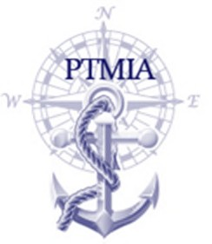
PORT OF TAMPA MARITIME INDUSTRIES ASSOCIATION
OFFICERS AND DIRECTORS

2020-2021

BOARD OF DIRECTORS

Shipping & Transport
TOM MILLINER Seabulk

Shipyards
JOHN GALLAGHER Gulf Marine Repair
GEORGE LORTON International Ship Repair

Terminal Operators
PETE EARNEST SATCO
BRADY BREAUX MOSAIC
PHIL MASSIE YARA NORTH AMERICA
PETER TIBBET CITGO

Passenger Vessels/Ferries
BILL KUZMICK American Victory Ship
TROY MANTHEY Yacht Starship

Ship Agents/NVOCCs
ARTHUR SAVAGE A.R. Savage & Son

Contractors, Subcontractors
DENNIS MANELLI Hendry Marine Industries
RUSSELL LANCASTER Interbay Coatings

Service Providers and Vendors
KENNETH MISEMER Hancock Bank
CONRAD PALERMO Amerisafety, Inc.
JIM SERGEY NRCC

Professionals
DARREN RICAHARDS Tucker-Hall
TONY CUVA Bajo Cuva Cohen & Turkel

Associate Members
TIM SHUSTA
JERE WHITE
HARRY COSTELLO
RICK WATTS

